Name: Date:
Geography Practice
*Use very good handwriting, and make sure you spell correctly.
Answer each question using your map.
MUST have name and date.
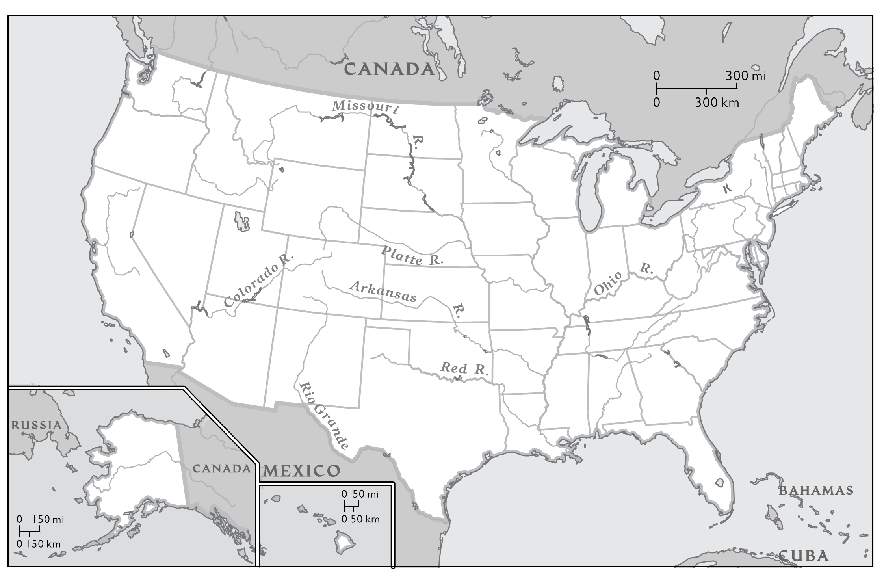
These are the States along the Canadian Border. Put a number in the state when you find it.

- Washington
- North Dakota
- Minnesota
- Wisconsin
- Idaho
- Michigan
- Pennsylvania
- New York
- Vermont
- New Hampshire
- Main

