Name: Date:
Geography Practice
*Use very good handwriting, and make sure you spell correctly.
Answer each question using your map.
MUST have name and date.
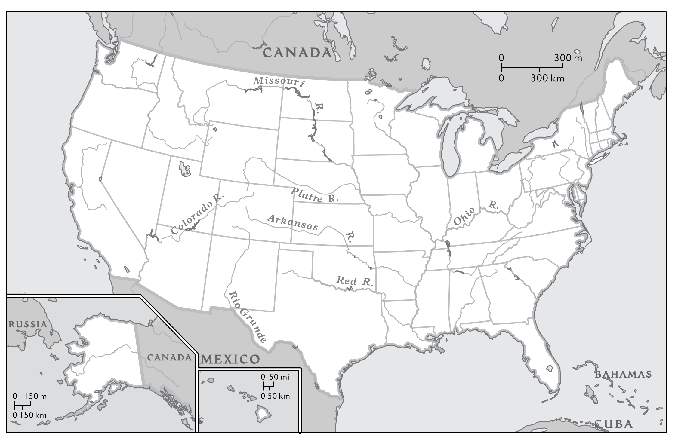
These are the States along the Gulf of Mexico. Put a number in the state when you find it.

- Texas
- Louisiana
- Mississippi
- Florida
- Alabama

