Name: Date:
Geography Practice
*Use very good handwriting, and make sure you spell correctly.
Answer each question using your map.
MUST have name and date.
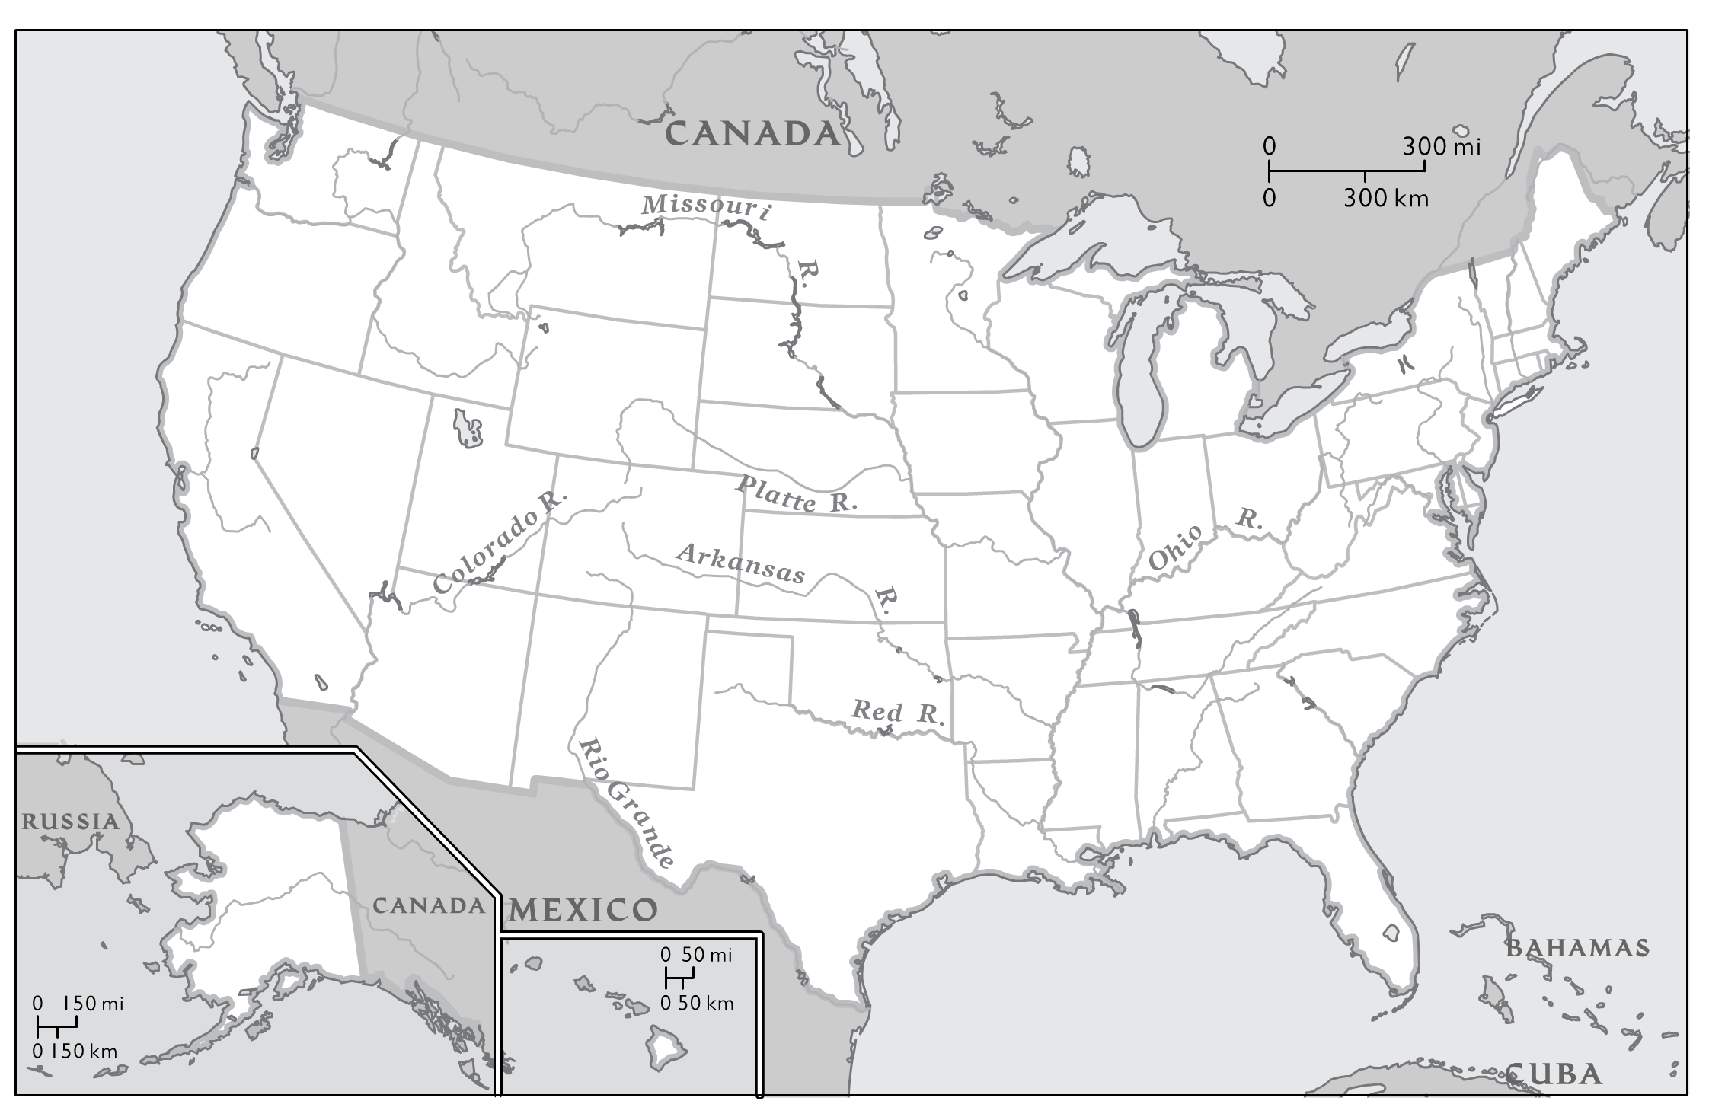
These are the West Coast States. Put a number in the state when you find it.

- Washington
- Oregon
- California
- Utah
- Idaho
- Nevada
- Arizona
- Colorado
- Montana
- Wyoming
- New Mexico

