Name: Date:
*MUST write your name neatly, and the date correctly.

Texas Geography Reference Sheet

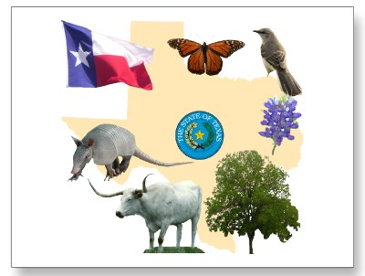
Texas State Symbols

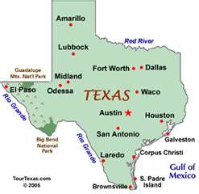
Texas Major Cities
*Clue: the state capital always has a star next to it.

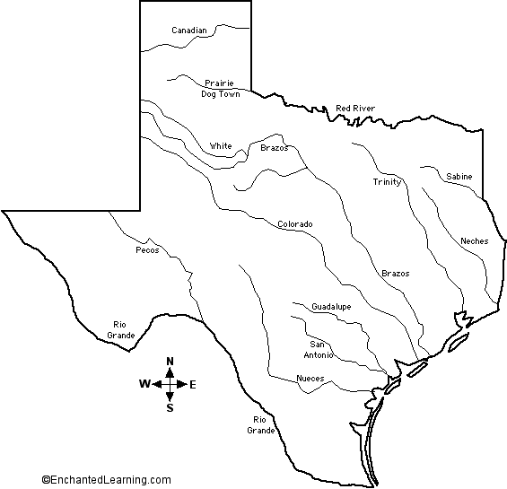
Texas Major Rivers

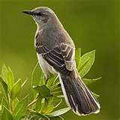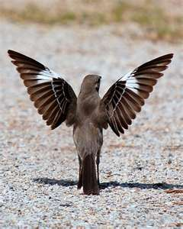
Texas State Bird: the Mockingbird

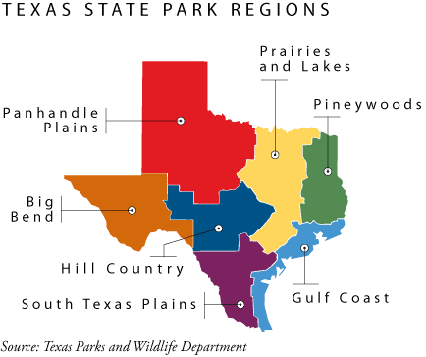
Major Texas Regions

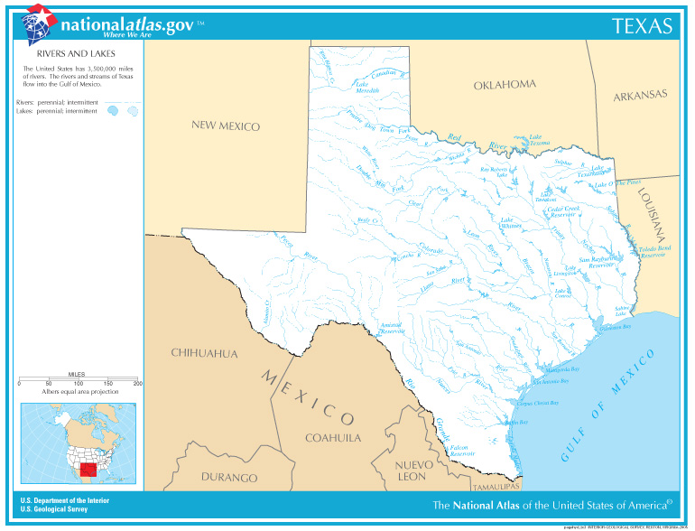
Texas State Neighbors

