Name: Date:
*Must have your name and date written above.
The Human Body
*Label the bones on the skeleton.

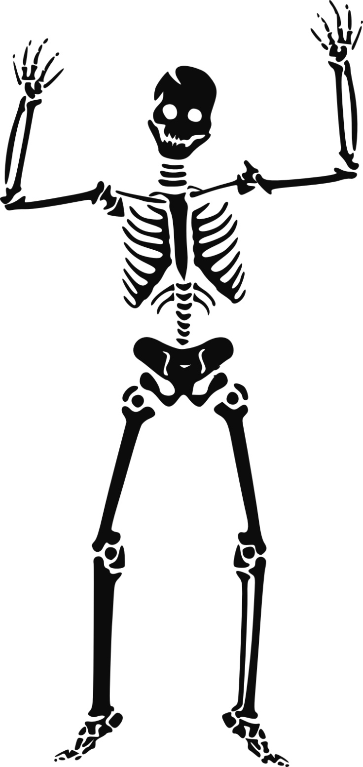
Word BANK:
Ribs
Brain (cranium)
Jaw (mandible)
Hips (pelvis)
Femur (thigh)
Shin (Tibia)
Sernum
Wrist (Ulna)
Fingers (Philanges)
Clavicle
Toes (Metatarsals)
Spine

